Mustache to Touch – Visualizing Model Risk for Exotics

Uwe Wystup, MathFinance AG, Frankfurt am Main

For vanilla options, the volatility smile shows the implied volatility in the Black-Scholes model and is interpreted as the deviation of the market from the normal returns assumed by the Black-Scholes model. Since the relationship of volatilities and vanilla option prices is monotone, this way to visualize the market- or model-implied deviation is the established standard.

We visualize the USD/JPY volatility smile of the market data of 23 January 2018 in Figure 1. Spot reference was 110.31 and out-of-the-money puts are higher priced than out-of-the-money calls (equivalently in-the-money puts).

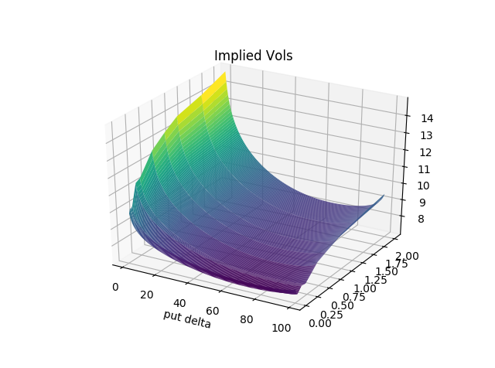

Figure 1: USD/JPY volatility surface of 23 Jan 2018, put forward delta on the x-axis, time to maturity on the y-axis, implied volatility on the z-axis – raw data sourced from Bloomberg, surface built by MathFinance.

Therefore, for pricing vanilla options, it is common to use the Black-Scholes formula, and all the quantitative/modeling work is shifted to and hidden in the way the volatilities are interpolated and extrapolated on both the strike-space and maturity space (**Smile**). It is only for pricing exotics that we really need a model. The common industry models include vanna-volga (**Vv2**), local volatility (**Lv**), stochastic volatility (**Sv100**) and stochastic-local-volatility mixture models with a mixing factor of 75% (**Slv75**), where 75 is just an example.

We visualize in Figure 2 how the models can be calibrated to the vanilla options market: Obviously, **Smile**, **Lv** and **Slv75** fit the vanilla option prices by construction and exhibit a flat line. **Vv2** and **Sv100** don’t fit the vanilla smile perfectly, particularly not on the wings. **Vv2** does not take the information beyond 25-delta into account, thus a good fit for low deltas or far away strikes is not expected. **Sv100** does to the best possible fit via minimization of the distance of the model from the market. Consequently, even this stochastic volatility approach is not expected to yield a perfect fit.

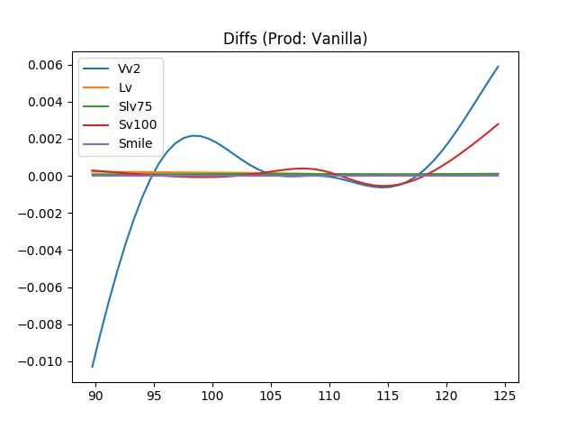

Figure 2: USD/JPY model fit of 23 Jan 2018, strike on the x-axis, and differences to ATM volatility on the y-axis, raw data sourced from Bloomberg, calculations by MathFinance.

This was the reason why 100% stochastic volatility models, like Heston, needed a local-volatility model mix, to fit the market input consistently. Local volatility models alone can fit the vanilla option prices for one maturity perfectly, but tend to misprice path-dependent claims, e.g. tend to overprice touch contracts. Therefore, one either starts with a stochastic volatility model, adds a local volatility to straighten up calibration to fit the vanilla option prices, or one starts with local volatility models and mixes them randomly, the so-called local-volatility mixture approach.

We illustrate the effect for a 9-month one-touch contract in USD/JPY with a touch-level below initial spot (TouchDown). A common way to visualize the model-impact is to use the x-axis for the theoretical value (**TV**) of the One-Touch, and the difference to the **TV** on the y-axis for the other models. Remember **TV** stands for **T**heoretical **V**alue, not **T**ele**V**ision, and represents the value calculated in the Black-Scholes model using the at-the-money volatility without applying and smile or term structure. The **TV** is used by market participants as a checksum. Note that the touch level is varied to create **TV**s ranging from 0=0% (touch level very far from spot) and 1=100% (touch level on the spot). As a result, the **Slv75** comes to lie between the **Sv100** and the **Lv**, as can be see in Figure 3.

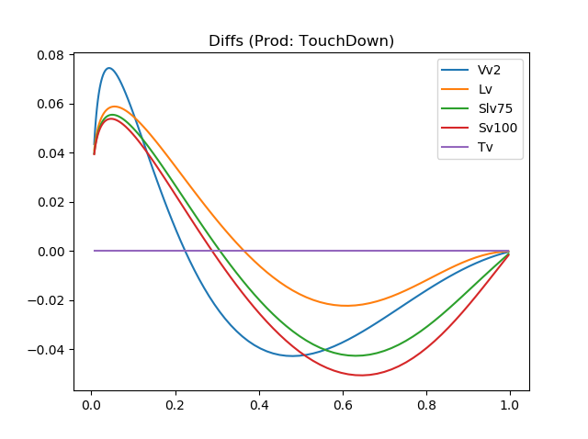

Figure 3: USD/JPY exotics model comparison of 23 Jan 2018, TV of a 9-month One-Touch with a lower barrier on the x-axis, and differences to TV on the y-axis, raw data sourced from Bloomberg, calculations by MathFinance.

The mixture parameter, which is chosen to be 75% in our example, can be calibrated to One-Touch prices, if they are available. We also notice that the vanna-volga approach **Vv2**, while similar to the other models, is slightly off; therefore, there are market participants using **Vv2** for valuation purposes, but a market maker quoting bid and offer prices with a spread of 0.02=2% could potentially be off-market when using **Vv2**.

This way of illustrating the smile effect for exotics is called the *mustache*. The reason is that, if you also consider the graph for the One-Touch contracts with an upper barrier in Figure 4, and paste the two graphs next to each other, TouchUp on the left, TouchDown on the right, the combined shape resembles a mustache and is shown in Figure 5. Very touchy.

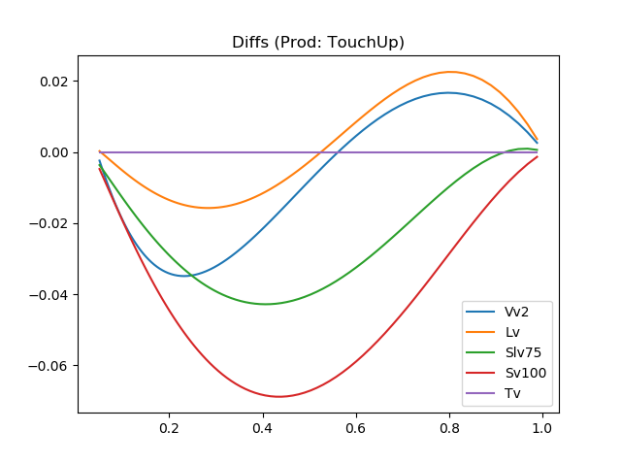

Figure 4: USD/JPY exotics model comparison of 23 Jan 2018, TV of a 9-month One-Touch with an upper barrier on the x-axis, and differences to TV on the y-axis, raw data sourced from Bloomberg, calculations by MathFinance.

The mustache can be used to visualize how different pricing models capture the volatility smile and can be part of a quantitative model risk analysis. Nowadays, regulators normally require banks to conduct a *model risk analysis* for all new products to be traded. For front-office it is an important tool to gauge the quality of the in-house model. For this purpose, a number of models need to be implemented, calibrated and contracts priced. For the high-speed, low-tolerance FX derivatives market, gauging and monitoring model risk is crucial for survival.

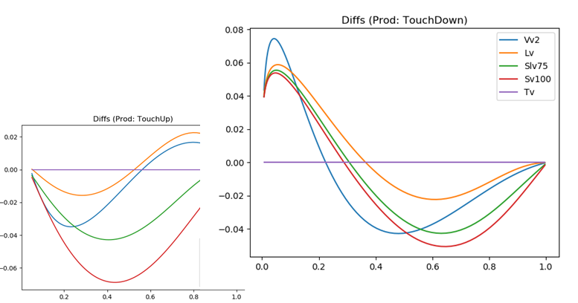

Figure 5: USD/JPY OneTouch Mustache of 23 Jan 2018, TV of a 9-month One-Touch on the x-axes, and differences to TV on the y-axis, raw data sourced from Bloomberg, calculations by MathFinance.

For touch contracts, note that the interbank bid-offer spread is about 0.02 = 2% for liquid currency pairs; therefore, the difference of the models matters crucially for those making exotics tradable on their platforms. In practice, the weighting factor, which we chose to be 75% for illustration purposes, is calibrated to observable prices of touch contracts and is often rather stable, but depends on the currency pair.