**FX Column: KIKO Double-Touch, Parisian Options and Triangular Relationships**

Uwe Wystup, MathFinance AG, Frankfurt am Main

Talking about FX Options and Structured Products, there are many terms popping up with a meaning outside financial markets. Some, when talked about outside the options trading community can insinuate suspicious activities, so to clarify for good, let me highlight a few in this FX column.

**TV**

TV is normally the abbreviation for television, but in the context of FX options it refers to the **T**heoretical **V**alue of an option or other derivative, which is the value calculated in the Black-Scholes model assuming constant volatility and interest rates, i.e. without the smile effect or other considerations. The purpose of the TV is to have a checksum, so both the seller and the buyer can double check if they are talking about the same product, which is particularly relevant for structured products like faders, accumulators and target forward contracts.

**KIKO Double Touch**

This term when inserted in a web search engine leads to the Milan based cosmetics company KIKO[1]. In financial terms it refers to a touch contract with two barriers, one being a knock-in (KI), the other a knock-out (KO) barrier. Indeed a therapist once ordered a box of 30 KIKO double touch from the MathFinance office after browsing the company website 😊. A typical financial application of a KIKO comes up in a Target Redemption Note, where for each fixing the payoff as in Figure 1 has an upper knock-out barrier (American style) and a lower knock-in barrier (European style).

Figure 1: AUD-JPY KIKO TARN Payoff in AUD.

**Wedding Cake**

Double-Touch contracts are common building blocks in wedding cakes, structured investment products also referred to as *onions*, or *towers*, with nested ranges of double-no-touch contracts displayed in Figure 2. In a wedding cake deposit the investor receives a guaranteed capital and a worst case coupon below market, which is often taken to be 0% (or a negative coupon if market is already near or below 0%), and then builds up higher coupons like in a tower depending on which range the underlying exchange rate remains. Hence, the wedding cake deposit reflects a view on a sidewards movement of the underlying exchange rate. The investor waives parts of her market coupon and takes a position that is equivalent to going long a portfolio of nested double-no-touch contracts, whose notional is in the deposit currency, and whose amounts are based on the differences between the interest rate amounts of two successive coupons. Since the ranges are nested, there are other names for this structured deposit such as *multiple range deposit* or *onion deposit* or *tetris bond*.

Figure 2: Wedding Cake Structure.

**James Bond Range**

As James Bond can only live twice, the James Bond Range is a double-no-touch type contract. Given an upper barrier C and a lower barrier B, it pays one unit of currency, if the spot remains inside (B,C) at all times until expiry T, or if the spot hits B the spot thereafter remains in a new range (A,C) or similarly, if the spot hits C the spot thereafter remains in a new range (B,D). The contract is also called tolerant double-no-touch, see Figure 3. The payoff can be replicated statically by a portfolio of standard double-no-touch contracts (exercise!).

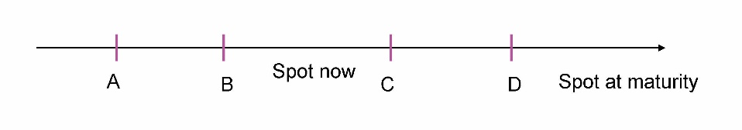

Figure 3: James Bond Range.

**Butterfly Forward**

For many, a butterfly forward is a yoga pose as in Figure 4.



Figure 4: Butterfly Forward Yoga Pose.

In currency risk management it refers to a combination of a synthetic forward with a contractual forward rate worse than outright and a double-knock-out straddle as in Figure 5. In the example a corporate treasurer client agrees on a worst case final exchange rate to buy EUR (or sell USD), slightly above the market outright forward, and in return gets a better (i.e. lower) final exchange rate if the spot moves either up or down close to either a prespecified upper or lower barrier but not beyond.

Figure 5: Butterfly Forward Final Effective Exchange Rate in EUR USD.

And by the way, in the options context, BF doesn’t mean *best friend*, but **b**utter**f**ly.

**Shark Forward**

In currency risk management a shark forward refers to a combination of a synthetic forward with a contractual forward rate worse than outright and a long reverse-knock-out (RKO) barrier option. The final effective exchange rate is displayed in Figure 6. In the example a EUR-zone based importer agrees to buy USD (sell EUR) at a rate slightly lower, i.e. worse than the outright forward indicated by the dotted line, and in return benefits from a rising spot up the upper barrier level. It has not been finally examined if the marketing term shark really encourages treasurers to trade the shark forward contract, or whether it rather scares them. Other terms like forward plus or forward extra are more compliant, I guess.

Figure 6: Shark Forward Strategy with Final Exchange Rate.

**Triangular relationship**

Talking about the triangular relationship in the context of currencies and currency options means that if we know the price of 1 EUR in USD and the price of 1 USD in JPY, we can easily defer the price of 1 EUR in JPY, simply by multiplying the spot rates EUR-USD and USD-JPY. This implies in the currency triangle displayed in Figure 7 that the volatilities between the currency pairs EUR-USD, USD-JPY and EUR-JPY are geometrically related and correlations between the log-spot rates are implied from volatilities, just like angles can be computed from the sides via the law of cosine. So it is only math, but rather beautiful math.

Figure 7: Currency Triangle

**Vanna**

Vanna, a term I had only encountered in finance, could refer to a women’s watch, a singer, an MIT-licensed open-source python RAG (Retrieval-Augmented Generation) framework for SQL generation and related functionality, and what have you. But, luckily it is just the second order mixed derivative of a derivative’s value with respect to volatility and spot. For a vanilla option vanna is displayed in Figure 8. Vanna being part of the set of so-called Greeks is not a Greek letter. Rumors say it goes back to the question “wanna lose a lot of money?” by a Citibank head quant in the 90s who had written an article in Risk Magazine about the importance of hedging exotics’ vanna positions. Wanna had to be replaced by vanna, because it had to fit in the general v-pattern of volatility, vega, all starting with the letter v.

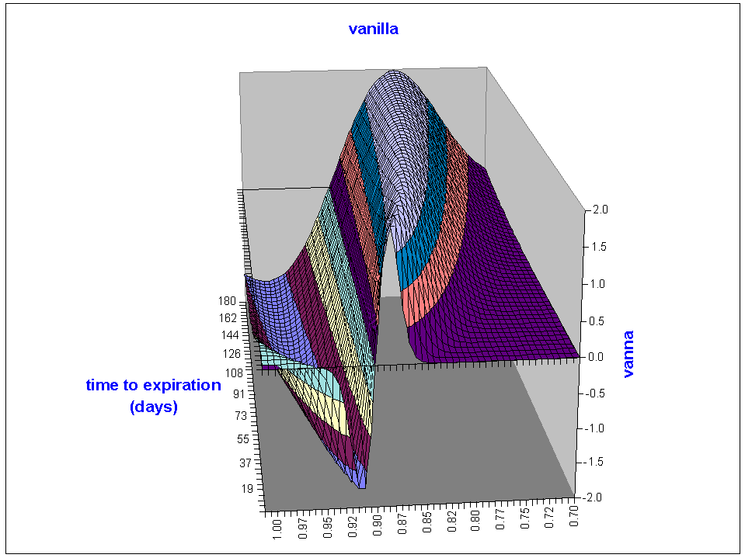

Figure 8: Vanna of a Vanilla Option.

**Volga**

Volga does not refer to the river in Russia but the second derivative of a derivative’s value with respect to volatility. It is a shortened version of **vol**atility-**ga**mma, where gamma indicates a second derivative. For a vanilla option volga is displayed in Figure 9. Volga being part of the set of so-called Greeks is not a Greek letter.

Figure 9: Volga of a Vanilla Option.

Interview question: can vanilla volga be negative?

**And By the Way**

To distinguish a *straddle* from a *strangle*, we must remember that when strangling someone, there must be space between the hands, whereas straddling a block of wood requires a sharp ax-like device.

A *seagull* is a coastal bird, and its shape indicates the position of a long call spread and short option (Figure 10).

Figure 10: Seagull Payoff

A *condor* is a bird with a wide wing-span and its shape indicates the position of a long strangle with an inner range (typically 25-delta strikes) and short strangle with a wider range (typically 10-delta).

Rumors say that the holder of a *Parisian (barrier) option* can go to Paris no more than five times in a row to meet the woman of his desire until his marriage knocks out. The contract, originally invented by Société Générale, and after all in Paris, is a discretely monitored barrier option, where a knock-out event occurs if the spot fixing is above a pre-specified barrier at least five times in a row. (The number 5 is only an example!). For *Parasian options* the condition is 5 times in total.

*Tarn* does not refer to the French river in tarn valley, but is an abbreviation for **Ta**rget **R**edemption **N**ote; analogously, a *tarf* is a **Ta**rget **R**edemption **F**orward.

*Bufga* is short for **bu**tter**f**ly-**ga**mma and refers to the change of the derivative value caused by a change in the butterfly quote.

*Enoughga* is what people say, when they get fed up with Greeks.

**References**

* Wystup: FX Options and Structured Products, Second Edition, Wiley 2017.
* Wystup: FX Column “[KOAMKIEU and the psychology of derivatives in private banking](https://wilmott.com/wilmott-magazine-january-2022-issue/)”, Wilmott, volume 2022, issue 117, January 2022 pp. 20-21.
* Wystup: FX Column “Kiko Tarn revival in Asia”, Wilmott, volume 2020, issue 107, 30 May 2020, pp. 12-19.
* Wystup: FX Column “vanna-volga-and-the-Greeks”, Wilmott, volume 2020, issue 108, 30 July 2020, pp. 14-16.
* Wystup: FX Column “[Can volga of a long vanilla option be negative?](https://wilmott.com/wilmott-magazine-march-2022-issue/)”, Wilmott, volume 2022, issue 118, March 2022 pp. 16-18.
* FX Column [“FX Greeks”](https://onlinelibrary.wiley.com/doi/epdf/10.1002/wilm.10733), Wilmott, Volume 2019, Issue 99, 16 January 2019, pp. 16-19.
* Wystup: How the Greeks would have hedged correlation risk of foreign exchange options, [*Wilmott Research Report*](http://www.wilmott.com) August 2001.

11 January 2025 – MathFinance AG – Kaiserstraße 50 – 60329 Frankfurt am Main – Germany – www.mathfinance.com

1. https://www.kikocosmetics.com/en-ae/p/unlimited-double-touch-153-limited-edition-39865/?srsltid=AfmBOopC3okMdjZ0risBXtJaSxH2-cP1jHbn-1jVMoCVZhdYA95pmMEq